



2nd Semester DISM Project

Batch Code. PR2-2021-12 G+10G



Contents

Index

* Acknowledgment
* Our Team
* Problem Statement
* Screen Shots
* Source Code
* Data Base





ur Tea

**OUR TEAM**



|  |  |  |
| --- | --- | --- |
| NAME  WORK  STUDENT I’D | | |
| Bilal | **1351271** | **Project Manager**  **Front-end/Back-end** |
| Ahmed |  | Front-end  **Front-end** |
| M.Rahil |  | front- end  **Front-end**  **& Content**  o n t e n t |
| Saad kamaran | **1350103** | froCnotn-teenndt  **Front-end** |





Acknowledgement

Thanks to Almighty Allah, The most Beneficial and The most merciful, Who gave me mind to think and Heart to feel creativity & creation depends on thinking

Thanks to Almighty Allah, The most Beneficial and The most merciful, who gave me mind to think and Heart to feel creativity & creation depends on thinking

With His Grace & Mercy for giving me strength and ability to make me complete this Project. I would like to express our gratitude and appreciation to all those who gave us the possibility to complete this project, a special thanks to my teacher.

**Sir Najam Moin**, whose help, stimulating suggestions & encouragement, helped me to coordinate in my project. I would also like to express my deepest gratitude to my beloved parents whose well-wishes enabled me to transform my dream & thought into a reality.

I hereby presenting project in titled "**Sound**" in your hands. I have tried my consideration so that this project May become more effective & a better outlook to come. I earnestly hope that this project will provide all the necessary information required for the user to fulfill their requirement. However, suggestion for improvement of the project will be thankfully acknowledge.

With His Grace & Mercy for giving me strength and ability to make me complete this Project. I would like to express our gratitude and appreciation to all those who gave us the possibility to complete this project, a special thanks to my teacher.

**Sir Najam Moin**, Who's help, stimulating suggestions & encouragement, helped me to coordinate in my project. I would also like to express my deepest gratitude to my beloved parents whose well-wishes enabled me to transform my dream & thought into a reality.

I hereby presenting project in titled "**Sound**" in your hands. I have tried my consideration so that this project May become more effective & a better outlook to come. I earnestly hope that this project will provide all the necessary information required for the user to fulfill their requirement. However, suggestion for improvement of the project will be thankfully acknowledge.





Problem Statement

Music and Video ’s are the most c ommon source of entertainment today.

Music and Videos are the most common source of entertainment today.

SOUND Group wants to host a WEBSITE for Entertainment. Company is looking on hosting new and old Video’s and Songs in both REGIONAL and ENGLISH language.

WEBSITE should have proper menu structure and Music and Video should be arranged as per ALBUM, ARTIST, YEAR, GENRE, LANGUAGE etc.

Users should have option of reviewing and rating the Music and Video’s available.

Home Page should have information about the site and a section for latest music and video with 5-5 listing in each.

**Customer Specifications:**

Website will host information about songs and videos with images and description and “New” image/icon should flash along with the new additions to Music and Video’s.

The website will have three users/roles:

1. Administrator
2. USER

The Administrator should be able to do the following:

1. Add Music files with information.
2. Add Video files with information.
3. Create Categories viz. YEAR, ARTIST, ALBUM etc.
4. Delete Music files
5. Delete Video files.
6. Create/Manage Users/Logins
7. Manage information/details on the WEBSITE

Sound Group wants to h0st a Website for Entertainment. Company is looking on hosting new and old Video’s and Songs in both Regional and English language.

Website should have proper menu structure and Music and Video should be arranged

# as per Album, Artist, Year, Genre, Languages etc.

Users should have option of reviewing and rating the Music and Video’s aVailable.

Home Page should have information about the site and a section for latest music and video with 5 -5 li sting in each.

# Customer Specifications:

Website will host information about songs and videos with images and description and “New” image/icon should flash along with the new additions to Music and Video’s .

The web site will have three users/ro les:

1. Administrator
2. USER

# Zhe Administrator xhould be able to do the following:

* 1. Ad d Mus ic files with information
  2. Add Video files with information..
  3. Create Categories viz. Album, Artist, Year,
  4. Delete Music files
  5. Delete Video files.
  6. Create/Manage Users/L ogins
  7. Manage information/details on the Website





The User should be able to do the following:

The USER should be able to do the following:

1. Register/Create Account [USERID should be unique].

Note: Name, Address, Phone Numbers, Email-ids should be mandatory to be provided. Proper Validations should be applied on all Data Fields.

Project should be submitted along with proper documentation and Database Backup.

1. Re gis ter/ C rcate Acc oun I User Id s h o ul d bc uo iquc’|
2. Scarc h for M t1S I C /Vi de o base d on Nance . Art ist, Ye ar, A lbum e ie.

c ) Ad d M nd i fy kev iews

1. Ad d M0d i f y R at i Mfg s

N ote: Nala e, A dd res s, Ph one Nu mber s, Ema i I- i ds s h o ul d be man dator to be prov ided Proper Va I i dation s sh o o l d be appl i ed on all Data F i eld s .

from ccc show Id be subie i ttcd along wi th proper doc umcatat on and DatabdSL gC# LU.







Home Page











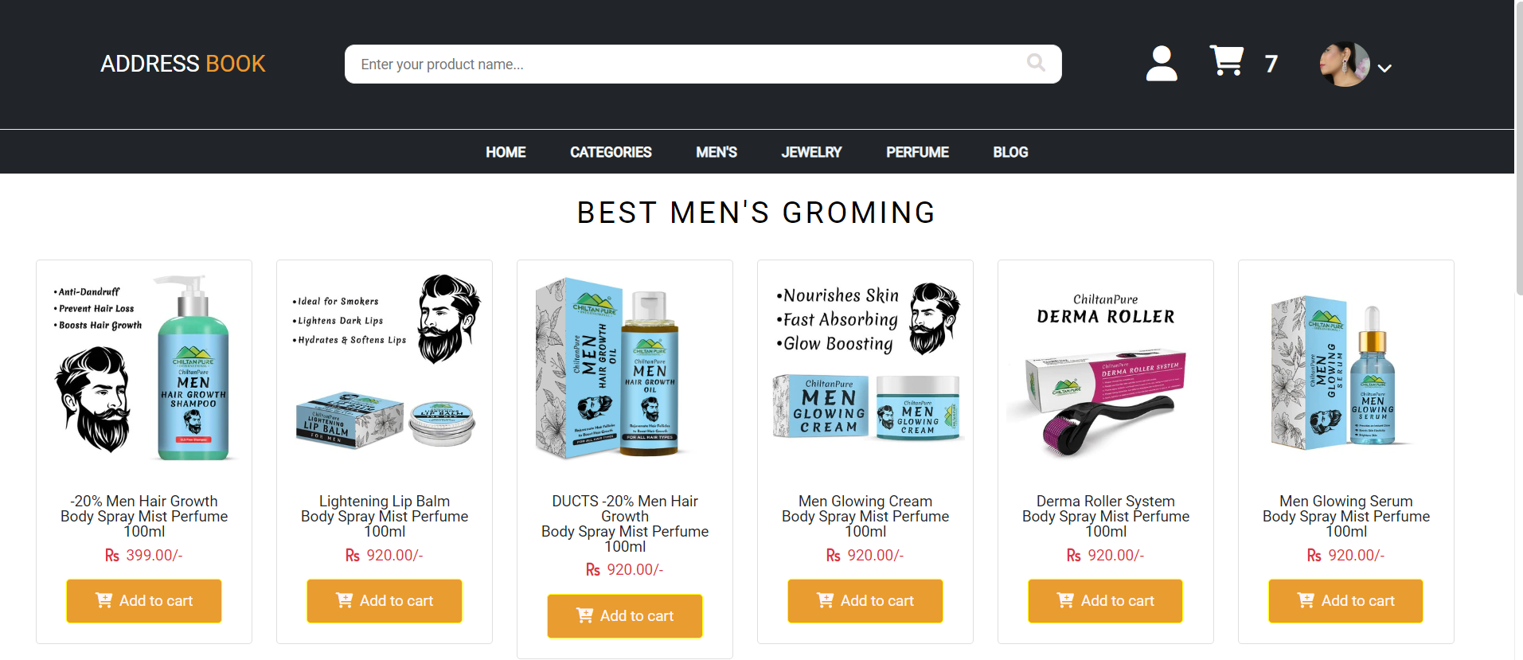







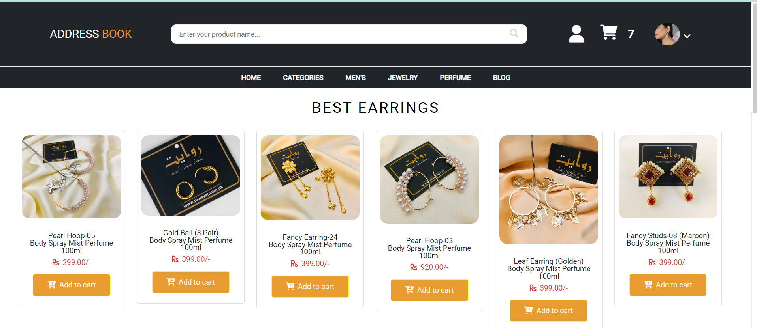







LATEST SONGS

LATEST VIDEOS



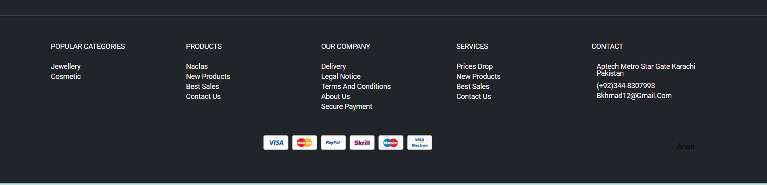



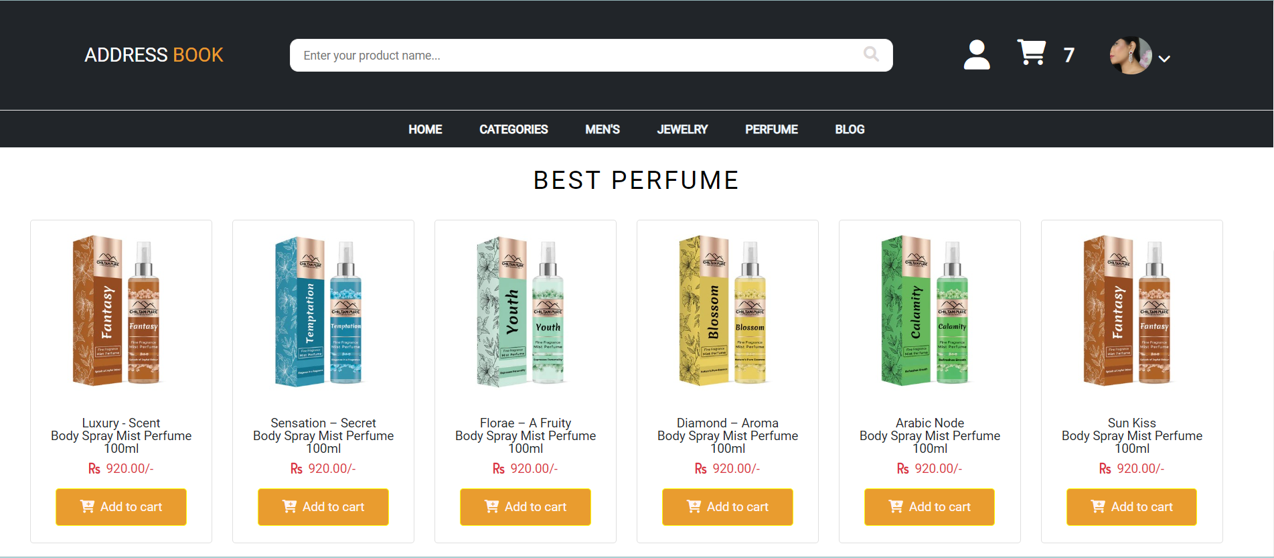





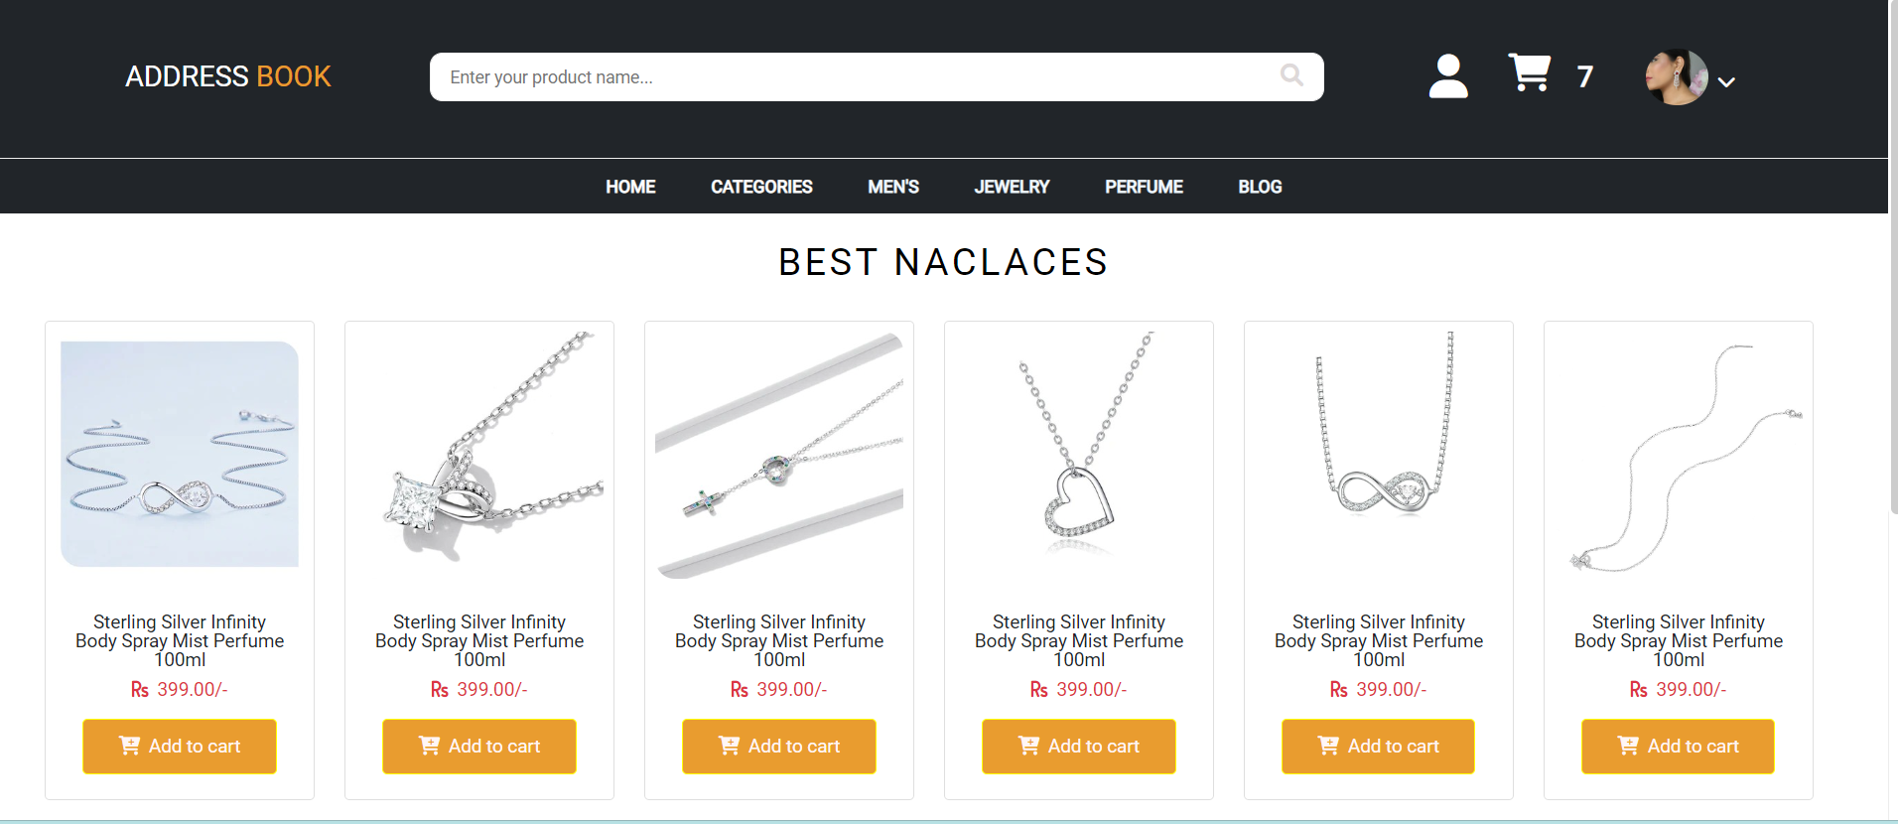





Profile & Setting









687





